Introduction
Our project focuses on the development of a functional and efficient database system for our client Universal Metals (pvt). The primary goal was to design a structured database that meets the company's data storage, retrieval, and management needs. By implementing a well-organized database solution, Universal Metals will be able to handle its operations more effectively, ensure data accuracy, and support future scalability.

About Client
Universal Metals (pvt.) LTD, a company established in early nineties and which is equipped with the latest imported plants in technical collaboration with DANUBIAN AIRCRAFT COMPANY Germany & Hungary for the production of Enamelled Copper Wire, Submersible Copper Wire, Paper Insulated Copper Strip and Copper Rod. By the grace of ALMIGHTY ALLAH we were able to broaden our production range with PVC Insulated Cables and Overhead Conductors based on the World's latest technology. Our Goal is to accelerate further utilizing the best quality raw material in Pakistan, 99.9% pure Copper & Aluminum, processed with strictest quality assurance measures during the production of Wires & Cables. With our aim to provide optimum performance we believe we could be a significant and helpful factor in the reduction of our client's electricity bills by providing easy flow of current with minimum resistance. Our manufactured wires and cables are used in machines and many other applications that involve the generation and the distribution of electrical energy. Our constant innovation and modernization justifies our product quality as new demands are continually emerging in the energy sector and these are the demands which we are fully prepared to meet. In the field of manufacturing various kinds of cables, we have been keeping up with rapidly advancing technical paces.

Location: Plot #215, Sundar Industrial Estate, Lahore

Email: universal.um3@gmail.com

EER Diagram
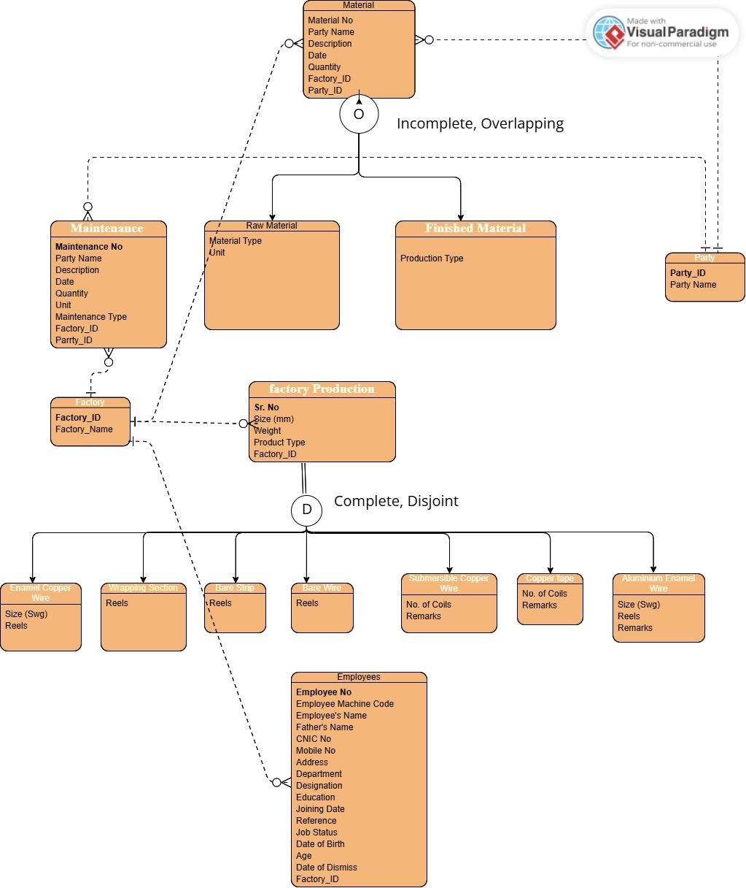

OUTPUT
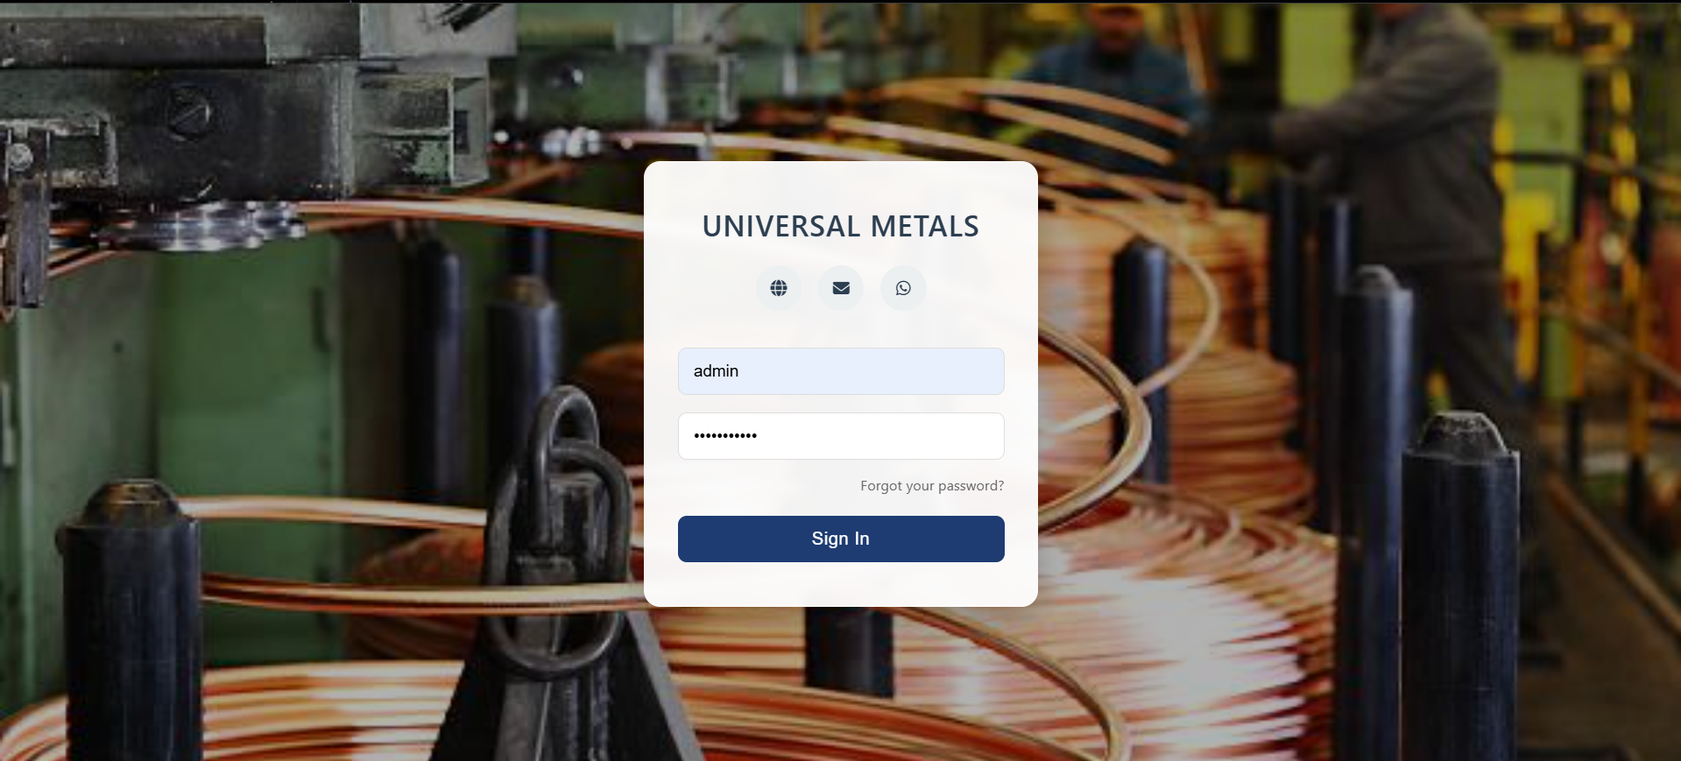
Login page
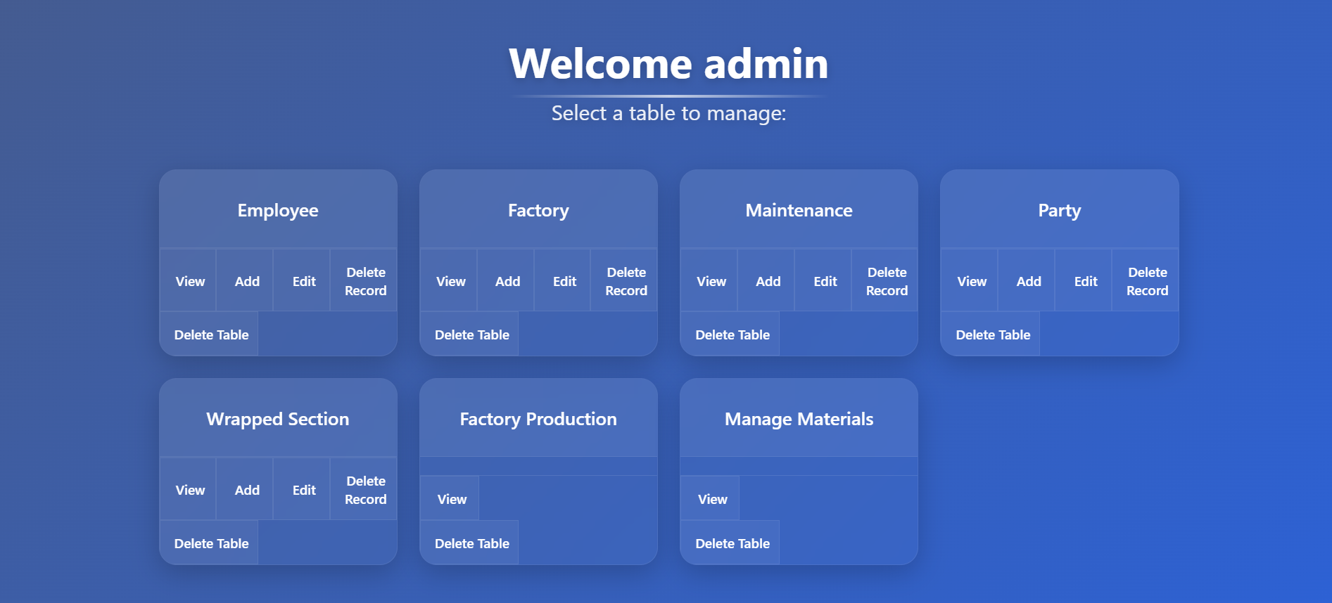Dashboard
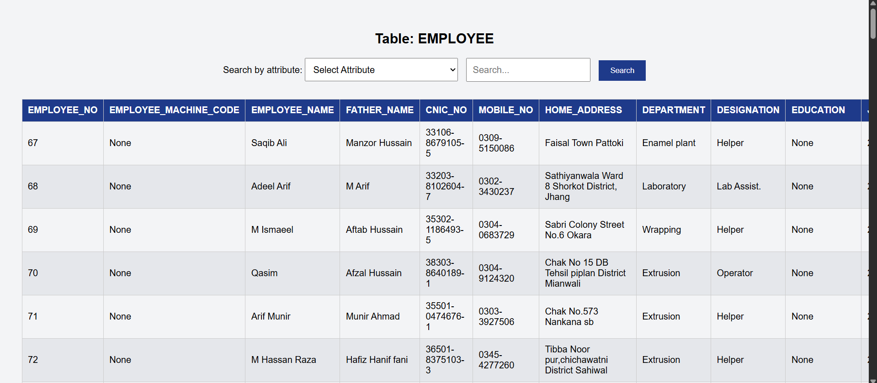Table view
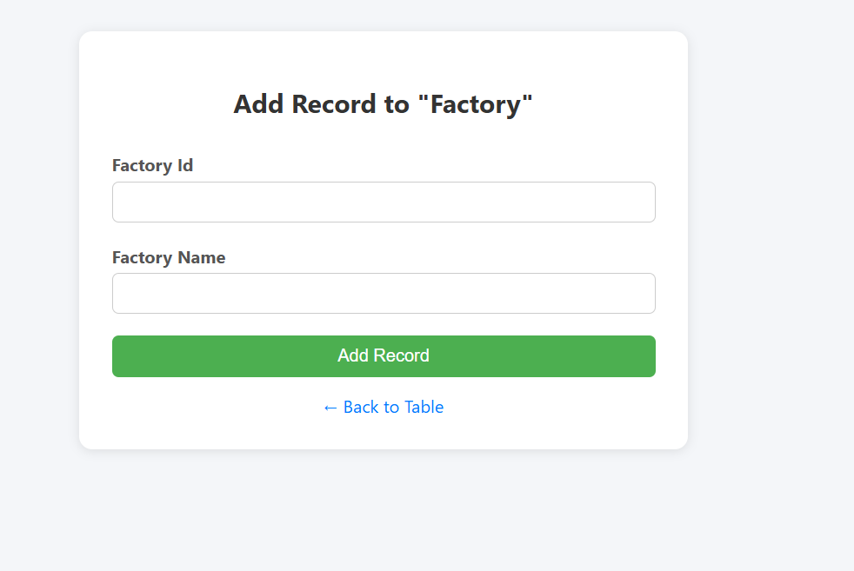Add record to a table
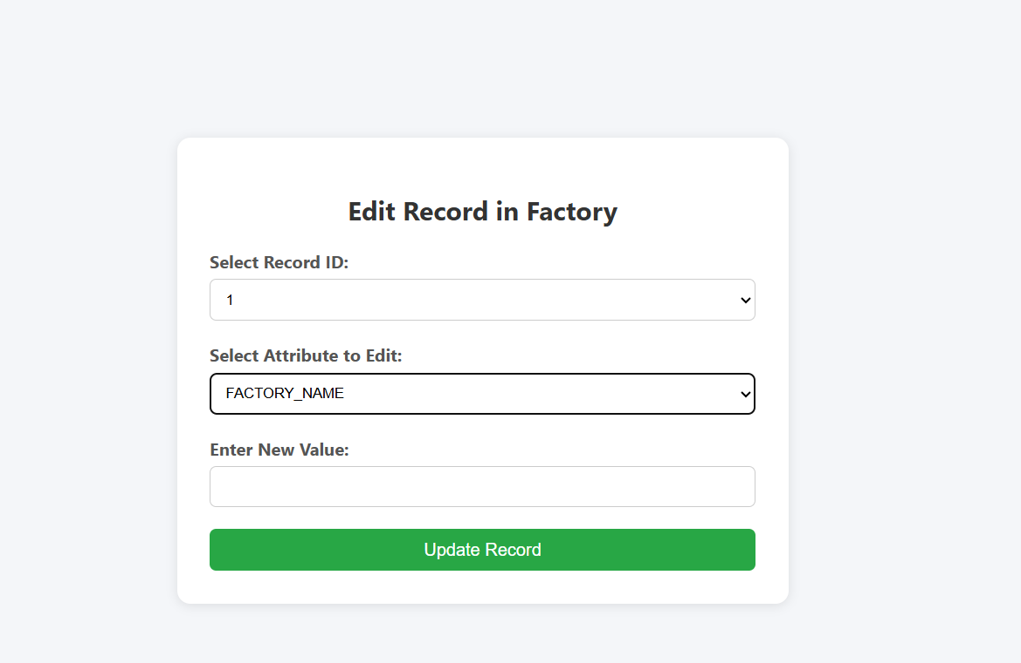Edit record in a table
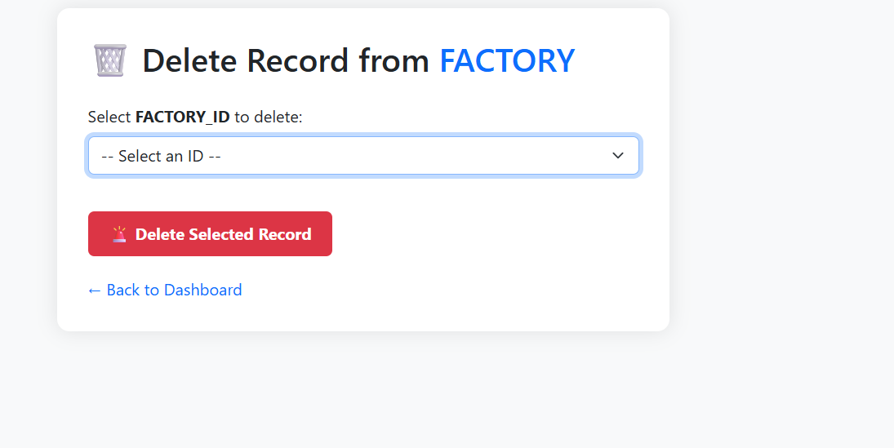Delete record from a table
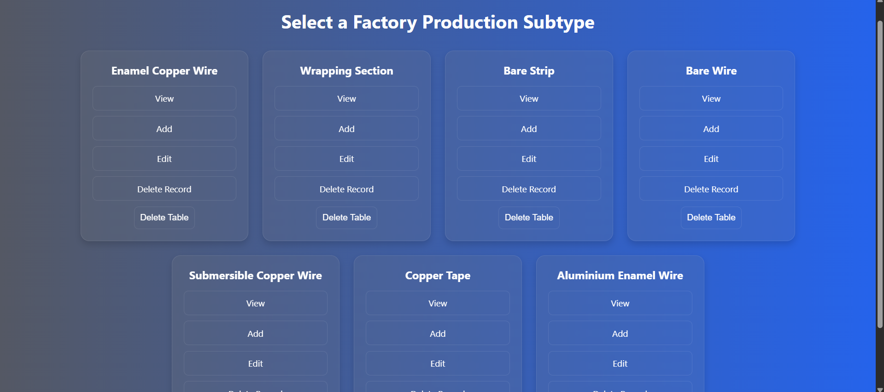Subtypes of a table

